Here are some activities you could do to make your cricket better

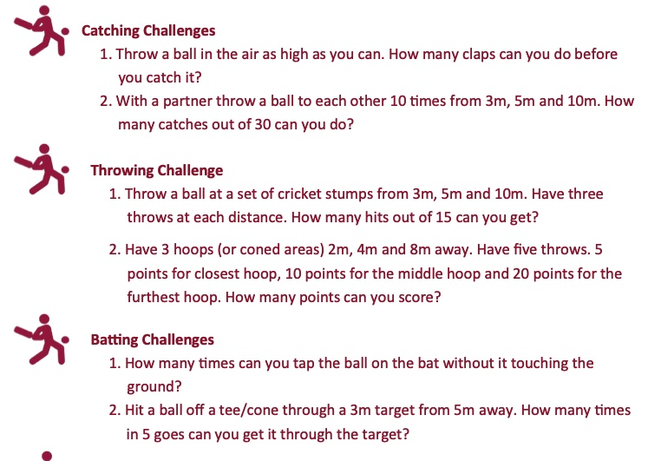

WHAT ACTIVITY OR GAME COULD YOU DESIGN TO HELP SOMEONE GET BETTER AT CRICKET

My activity will help a cricketer to improve: BATTING BOWLING. FIELDING (choose one)

This is what you have to do for the activity:

Here is a picture of what the activity will look like

Perhaps you could make a video of your cricket activity and send it in for our Community Coaches to try at school or for your friends to try at training.

