Design a Cricket Shirt

Here are some pictures of shirts that cricket teams wear.
Have a look at the shirts and see which design ideas you like. You might also like to look for your own ideas online.

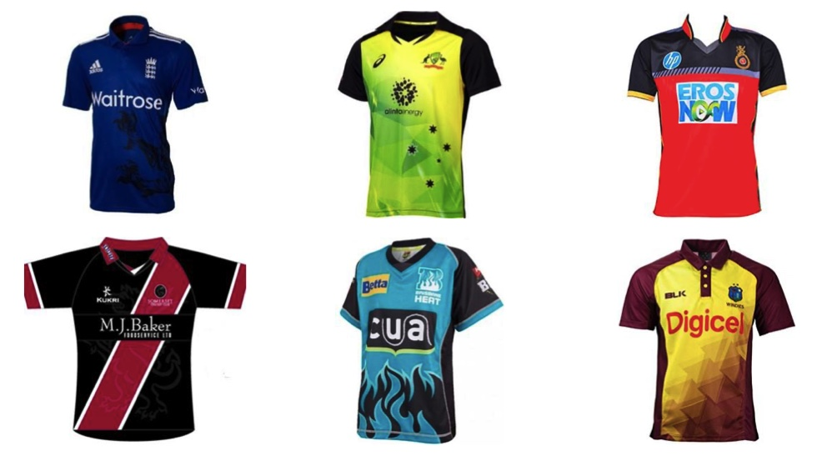

Use the picture below to print out and design your own shirt for your cricket team and cricket club.

