DATE PLAYED:
Team name |  | WON THE TOSS
AND ELECTED TO | BAT |  | FIELD
VS
AWAY
HOME
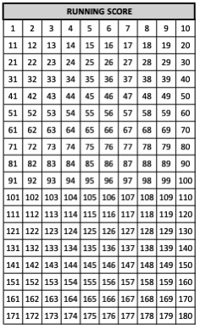
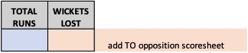
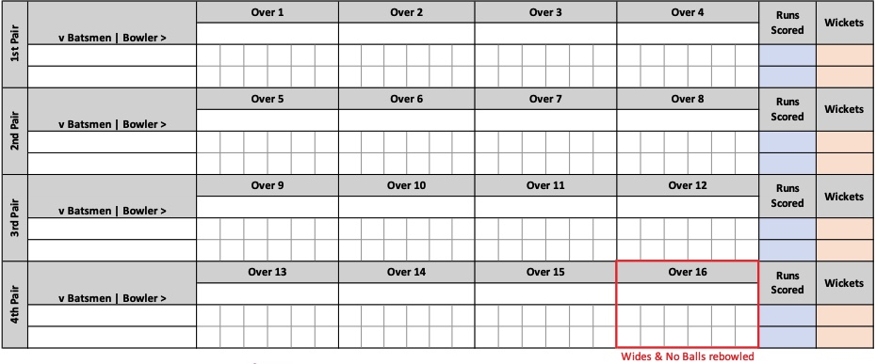
v Batter |Bowler >

v Batter |Bowler >

v Batter |Bowler >

v Batter |Bowler >

UMPIRES
SCORERS

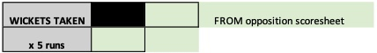

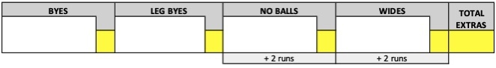
AGREED FINAL TOTAL

MATCH RESULT

Batter WICKETS TAKEN: Bowled(B), Caught (C), Stumped (st), Run Out (ro), Hit Wicket (hw)
WICKET | 1 | 2 | 3 | 4 | 5 | 6 | 7 | 8 | 9 | 10
HOW OUT
BATTER
BOWLER/FIELDER

