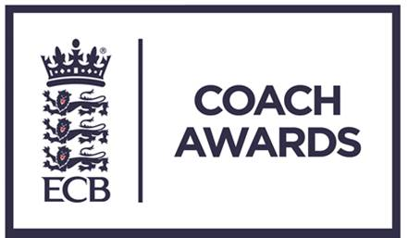

ECB Coach Awards 2017

These awards are a fantastic way of saying thank you to people who previously have gone un-thanked.

“Outstanding Contribution”

This person has been at the heart of things seemingly forever. They have probably played every role there is to play and without them cricket coaching in your club, in your league, your county or at your school just wouldn’t be the same or just would happen at all.

Does your hero do one or more of the following?

- Administrative support and or the development of coaching.
- The development and growth of coaches and or Coaches Association’s.
- Increased the number of coaches and or player participation.

If YES please nominate NOW and Help us to say “thank you”

County CA: _________________________________________________

Contact Name: _______________________________________________

Telephone: ___________________________________________________

E-mail: ______________________________________________________

“Outstanding Contribution”

Name of Nominee:

Address:

Telephone:

Email:

Date of Birth:
Current coaching / administration position:
Coaching qualifications (if applicable):
Number of years as coach / administrator:
How many hours per week do they commit to coaching / administration?
Professional status within cricket: | Full-time / Part-time / Voluntary  (Please circle or highlight)

Please outline below why you are nominating this person. Consider questions such as: How have they made a difference, the number of people this has applied to, the quality of what has been achieved.

