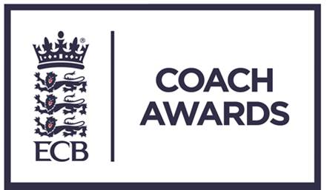

ECB Coach Awards 2017

These awards are a fantastic way of saying thank you to people who previously have gone un-thanked.

“Coach of the Year”

There are thousands of qualified coaches in clubs and schools up and down the country. Who goes the extra mile? Who makes a difference to you or your players, club or school? Who’s your coaching hero?

Does your coaching hero do one or more of the following?

- The development and success of players and teams
- The design, production and implementation of coaching programme
- Provide Innovation and inspirational coaching methods which have significantly improved player and team performances.

If YES please nominate NOW and help us to say “thank you”

County CA: ______________________________________________________

Contact Name: ____________________________________________________

Telephone: _______________________________________________________

E-mail:___________________________________________________________

“Coach of the Year”

Name of Nominee:

Address:

Telephone:

Email
Date of Birth:
Current coaching / administration position:
Coaching qualifications (if applicable):
Number of years as coach / administrator:
How many hours per week do they commit to coaching / administration?
Professional status within cricket: | Full-time / Part-time / Voluntary  (Please circle or highlight)

Please outline below why you are nominating this person. Consider questions such as: How have they made a difference, the number of people this has applied to, the quality of what has been achieved.

