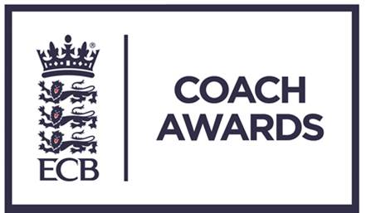

ECB Coach Awards 2017

These awards are a fantastic way of saying thank you to people who previously have gone un-thanked.

“Young Coach of the Year”

Do you know someone who’s already making a difference? Who’s already passing on their enthusiasm for the game and inspiring the next generation of players?
We are looking for young coaches who are 25 or under who you would like to say thank you to.

Does your coaching hero do one or more of the following?

- Shown a commitment to developing the game at grass roots and community level
- Has had a clear impact with a local school or club
- Shown creativity and determination in their development as a coach

If YES please nominate NOW and Help us to say “thank you”

County CA: ________________________________________

Contact Name: _____________________________________

Telephone: ________________________________________

E-mail: ____________________________________________

“Young Coach of the Year”

Name of Nominee:

Address:

Telephone:

Email:

Date of Birth:

Current coaching / administration position:
Coaching qualifications (if applicable):
Number of years as coach / administrator:
How many hours per week do they commit to coaching / administration?
Professional status within cricket: | Full-time / Part-time / Voluntary  (Please circle or highlight)

Please outline below why you are nominating this person. Consider questions such as: How have they made a difference, the number of people this has applied to, the quality of what has been achieved.

